
DUNCRAIG SENIOR HIGH SCHOOL
Question/Answer Booklet

2010
HUMAN BIOLOGICAL SCIENCE
STAGE 2A/2B

Name: ___________________________________________

Teacher: _________________________________________

Time allowed for this paper
Reading time before commencing work: 10 minutes
Working time for paper: 2 ½ hours

Materials required/recommended for this paper

To be provided by the supervisor
This Question/Answer Booklet
Multiple-choice Answer Sheet

To be provided by the candidate
Standard items: pens, pencils, eraser, correction fluid, ruler, highlighters
Special items: non-programmable calculators satisfying the conditions set by the Curriculum
Council for this course

Important note to candidates
No other items may be taken into the examination room. It is your responsibility to ensure that you do not have any unauthorised notes or other items of a non-personal nature in the examination room. If you have any unauthorised material with you, hand it to the supervisor before reading any further.

Structure of this paper

Section | Number of  questions  available | Number of  questions to  be answered | Suggested  working time  (minutes) | Marks  available | Percentage  of exam
Section One:  Multiple-choice | 30 | 30 | 40 | 30 | 30
Section Two:  Short answer | 9 | 9 | 90 | 100 | 50
Section Three:  Extended answer | 2 | 1 | 20 | 20 | 20
 |  |  |  |  | 100

Instructions to candidates

1. Answer the questions according to the following instructions.

Section One: Answer all questions on the separate Multiple-choice Answer Sheet provided. For
each question shade the box to indicate your answer. Use only a blue or black pen
to shade the boxes. If you make a mistake, place a cross through that square, do not
erase or use correction fluid, and shade your new answer. Marks will not be
deducted for incorrect answers. No marks will be given if more than one answer is
completed for any question.

Sections Two and Three: Write your answers in this Question/Answer Booklet.

2. Your must be careful to confine your responses to the specific questions asked and to follow any
instructions that are specific to a particular question.

3. Spare pages are included at the end of this booklet. They can be used for planning your responses
and/or as additional space if required to continue an answer.
- Planning: If you use the spare pages for planning, indicate this clearly at the top of the page.
- Continuing an answer: If you need to use the space to continue an answer, indicate in the
original answer space where the answer is continued. Fill in the number of the question(s)
that you are continuing to answer at the top of the page.

Section One: Multiple choice 30% (30 Marks)

This section has 30 questions. Answer all questions on the separate Multiple choice Answer Sheet
provided. For each question, shade the box to indicate your answer. Use only a blue or black pen to shade the boxes. If you make a mistake, place a cross through that square, do not erase or use correction fluid, and shade your new answer. Marks will not be deducted for incorrect answers. No marks will be given if more than one answer is completed for any question.

Suggested working time for this section is 40 minutes.

_____________________________________________________________________________________

1. Which of the following statements concerning cell membranes is true?

- Water passes freely through a cell membrane.
- A substance that is soluble in lipids will be repelled by a cell membrane.
- The size of a substance will not affect whether it passes through a cell membrane.
- Cell membranes allow all substances to pass through freely.

Question 2 refers to the diagram shown below.

The diagram below represents an experiment carried out in a school laboratory. A semi-permeable membrane separates two solutions. The membrane is only permeable to substances small enough to fit through the pores.
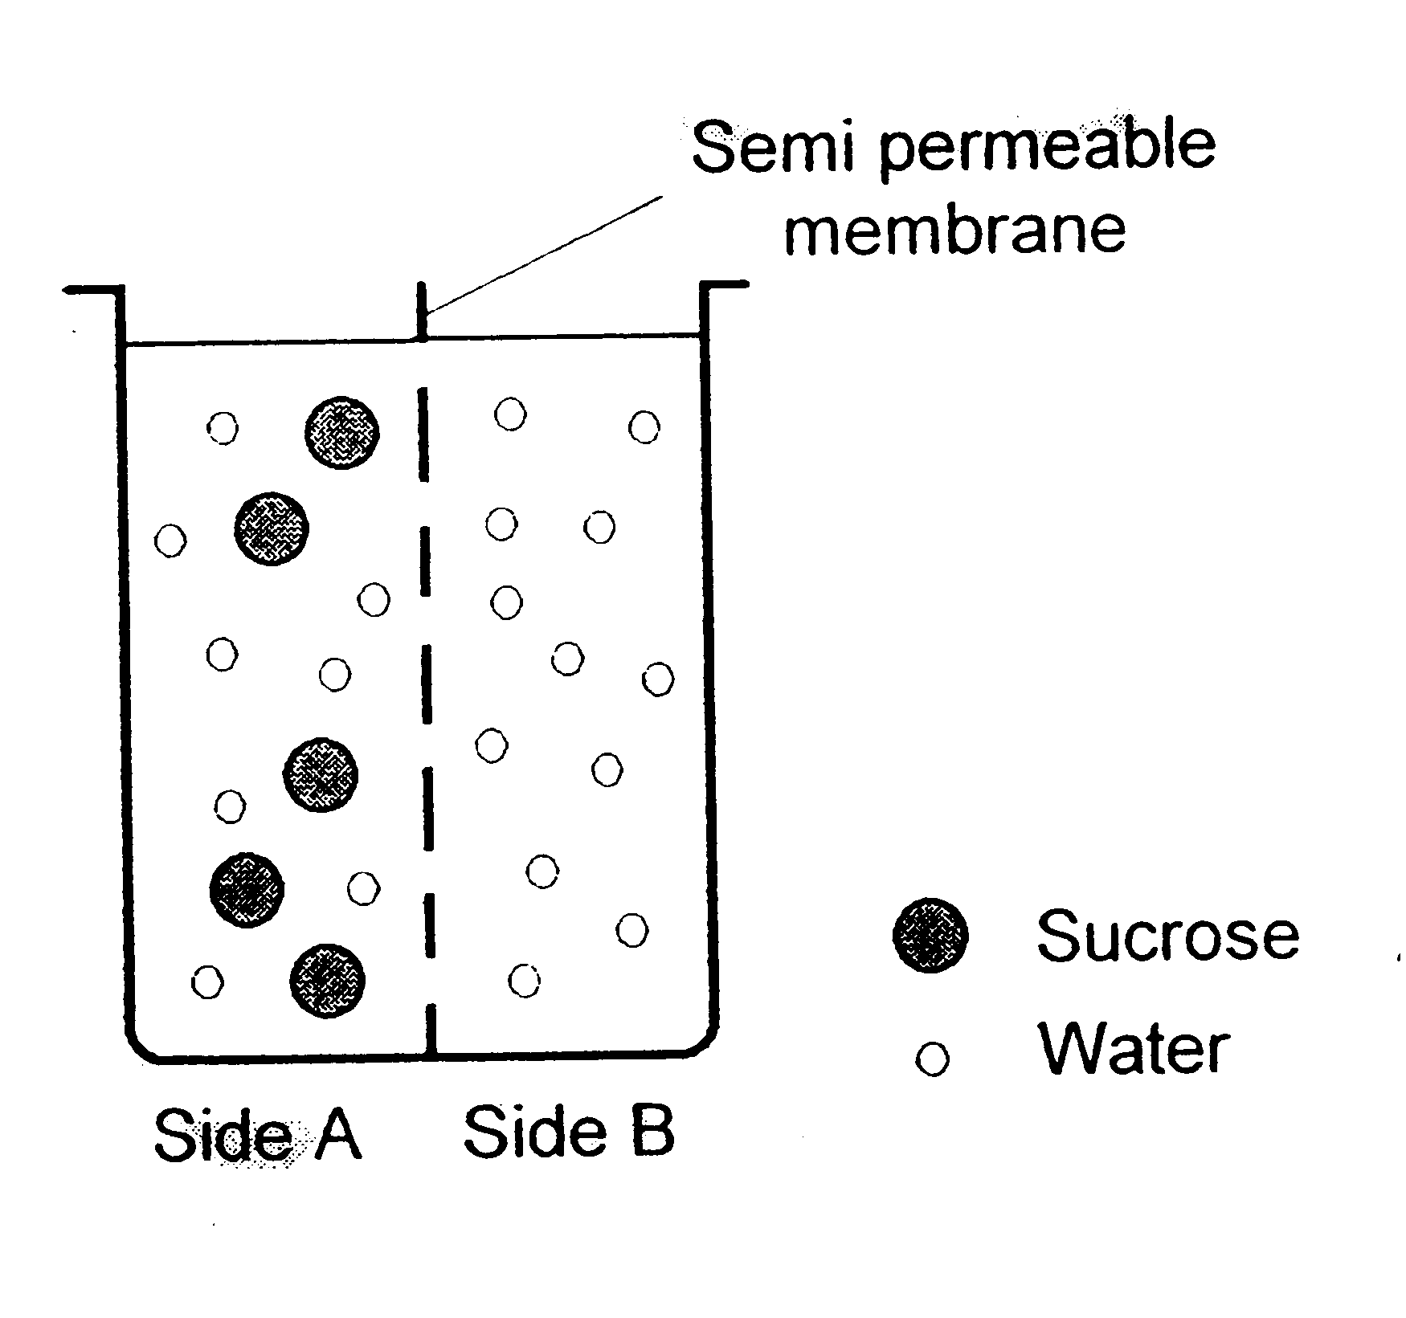
2. Which of the following statements is true?

- Osmosis will favour the movement of water molecules from side B to side A.
- There will be no net movement of water molecules.
- Sucrose molecules will readily diffuse from side A to side B.
- There will be no change in the volume of solution on either side of the membrane.

3. There is an upper limit on the size of a cell. Cells rarely grow much larger than microscopic size.
The explanation for this is that as a cell grows, its surface area to volume ratio

- decreases, causing it to lose heat too easily.
- increases, affecting its metabolism.
- increases, making it difficult to maintain cell requirements.
- decreases, making it difficult to obtain cell requirements.
4. Which of the following is not a component of the body’s external defence against disease?

- Wax in the ears.
- Alkaline conditions in saliva.
- Layers of mucous in the respiratory tract.
- Acid environment in the urethra.

5. Emulsification of fat

- is a form of mechanical digestion.
- is brought about by pancreatic lipase.
- requires an acidic environment.
- is a form of chemical digestion.

6. When glucose is broken down into carbon dioxide and water, most of the energy is

- used in cellular respiration.
- used for cell growth and division.
- released as heat to maintain body temperature.
- needed for the movement of cellular organelles and cell maintenance.

7. Consider the table below, which indicates the parts of the digestive tract where chemical digestion
of various foods occurs. An X indicates a positive result.

Section of Digestive  Tract | Food 1 | Food 2 | Food 3 | Food 4
Mouth | X
Stomach |  | X
Small intestine | X | X | X

Which food is most likely to be a piece of meat?

- Food 1
- Food 2
- Food 3
- Food 4

8. Compared to inhaled air, exhaled air should contain a higher percentage of

- oxygen, carbon dioxide and water vapour.
- nitrogen, carbon dioxide and oxygen.
- carbon dioxide and nitrogen.
- carbon dioxide and water vapour.

9. Which of the following risk factors for cardiovascular disease cannot be reduced by adopting a
health-sustaining lifestyle?

- Excessive alcohol consumption.
- Heredity factors.
- Physical inactivity.
- High blood pressure.

Questions 10 and 11 refer to the following graph.

The graph shows results from an experiment testing the effect of exercise on weight loss.

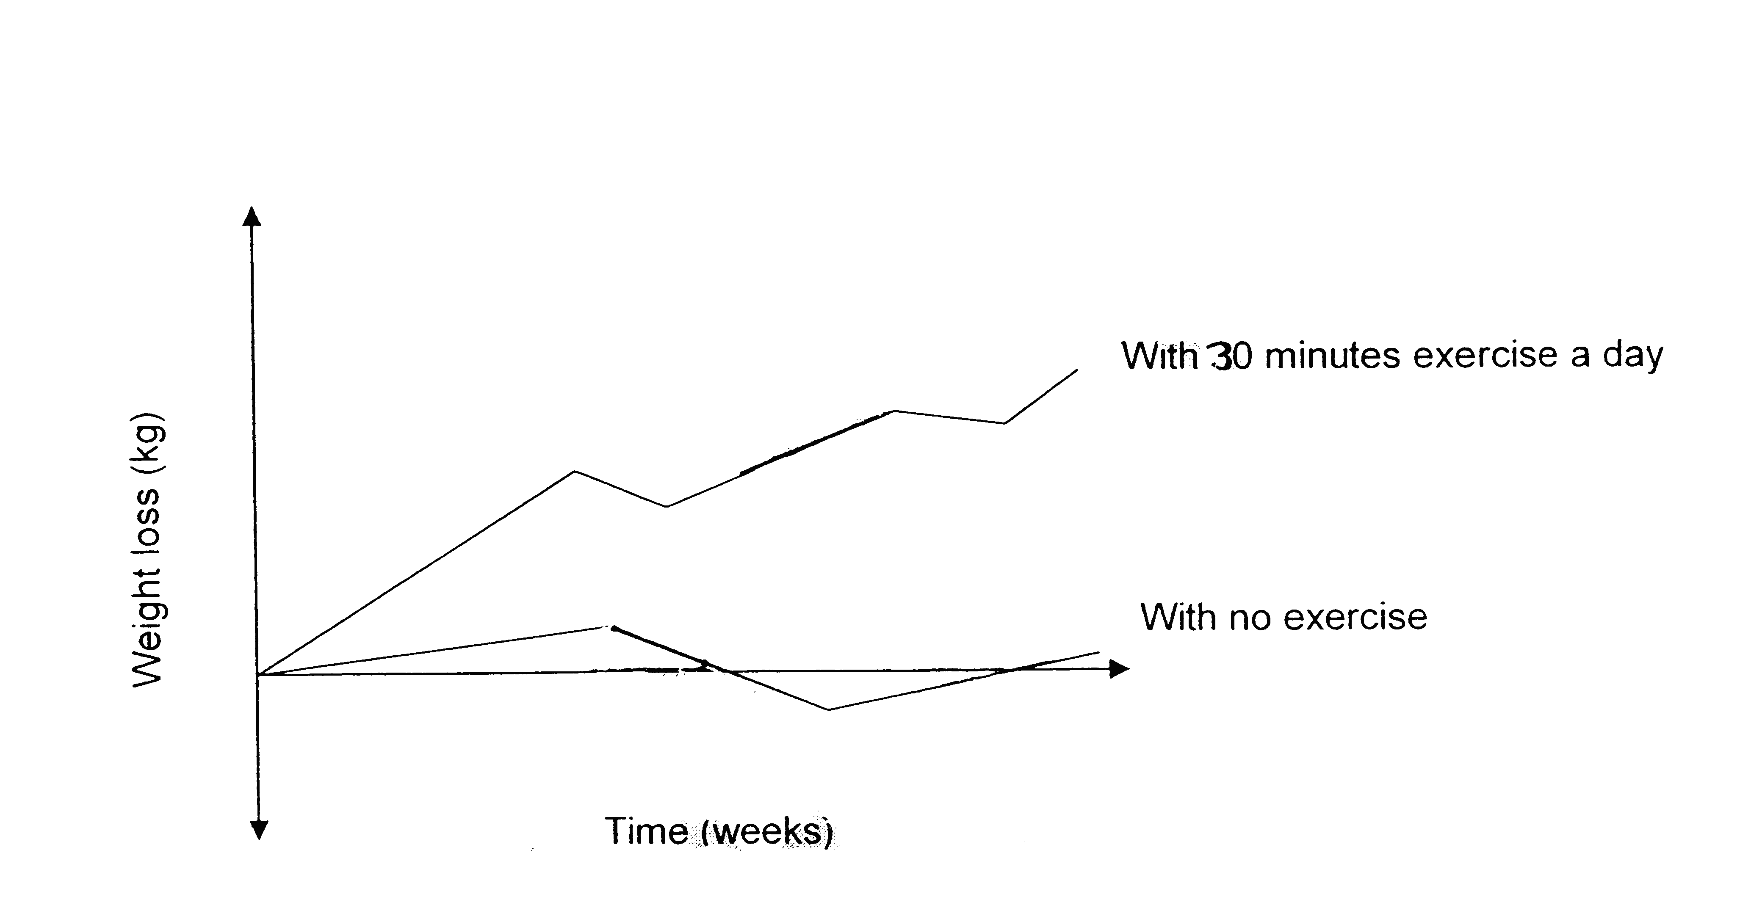

10. A logical hypothesis for the investigation could have been:

- A younger person will lose weight faster than an older person.
- Moderate physical activity will reduce body weight.
- If no exercise is undertaken a person can still consistently lose weight.
- Fitness can be altered with daily exercise.

11. The line on the graph showing ‘with no exercise’ is a representation of

- another investigation’s results.
- results from a repeat trial.
- the independent variable results.
- the control group results.

12. Which of the following is not a strategy people can undertake to help to reduce the spread of
disease?

- Wearing surgical masks.
- Covering their mouths when coughing.
- Wiping surfaces with disinfectant.
- Taking pain relief drugs.

13. Arteries

- carry deoxygenated blood to the tissues.
- normally join directly to veins.
- contain smooth muscle.
- carry blood back to the heart.
14. The pathway of air from the outside to the lungs would include:

- Nasal cavity, larynx, pharynx, trachea.
- Nasal cavity, trachea, bronchi, bronchioles.
- Nasal cavity, pharynx, larynx, trachea.
- Nasal cavity, bronchi, bronchioles, ribs.

15. Air enters our lungs because atmospheric pressure is

(a) greater than the pressure inside the lungs because the volume of the lungs has become
smaller.
(b) less than the pressure inside the lungs because the volume of the lungs has become
larger.
(c) greater than the pressure inside the lungs because the volume of the lungs has become
larger.
(d) less than the pressure inside the lungs because the volume of the lungs has become
smaller.

16. The active site of the enzyme molecule:

- is the location where the enzyme combines with the substrate.
- will attach to any substrate placed with the enzyme.
- requires activation energy to bind to the substrate.
- can never be altered in shape.

17. Which of the following are types of movement across the cell membrane requiring energy?

- Facilitated diffusion, active transport, pinocytosis.
- Osmosis, phagocytosis, exocytosis.
- Endocytosis, exocytosis, pinocytosis.
- Phagocytosis, pinocytosis, facilitated diffusion.

18. Excess protein cannot be stored in the body. Protein molecules are broken down in the liver
in a process known as;

- denaturation.
- excretion.
- defecation.
- deamination.

19. Urine is carried to the urinary bladder by;

- blood vessels.
- lymphatic vessels.
- the ureters.
- the urethra.

20. Which of the following statements is INCORRECT regarding the use of a placebo when testing a
new drug or treatment?

(a) The placebo should look identical and be administered in the same manner as the drug
being tested so the control group don’t realise they are not taking the drug.
(b) The group receiving the placebo are not expected to show an improvement in their condition.
(c) The group receiving the placebo should have a different result compared to the
experimental group to determine the change is due to the treatment being administered.
- The placebo can be used in medical treatment trials only.

21. Which of the following correctly describes the flow of blood through the heart?

- Bicuspid valve – right ventricle – semi lunar valve – pulmonary artery.
- Tricuspid valve – left ventricle – semi lunar valve – pulmonary artery.
- Bicuspid valve – left ventricle – semi lunar valve – aorta.
- Tricuspid valve – right ventricle – semi lunar valve – aorta.

22. Angina affects which part of the body?

- Lungs.
- Kidneys.
- Heart.
- Pancreas.

23. Structures called villi are found on the surface of the small intestine. Which of the following
statements about intestinal villi is INCORRECT?

- They provide a high surface area for nutrient absorption.
- They contain specialised blood capillaries known as lacteals.
- The cells on their surface are covered with tiny folds called microvilli.
- They are about 1mm in length.

24. At a wound you would expect to find;

- platelets, plasma, phagocytes.
- lymph nodes, lymphocytes, leucocytes.
- histamine, heparin, hormones.
- heparin, histamine, phagocytes.

25. Energy produced by cellular respiration is stored in the form of;

- glucose.
- ribonucleic acid.
- concentrated carbohydrate.
- adenosine triphosphate.

26. Mitochondria concentration would be highest in which of these cells?

- Nerve cells.
- Secretory cells.
- Muscle cells
- Red blood cells.

27. The rate of reaction of a typical human enzyme was compared with the rate of reaction of a
typical enzyme taken from bacteria that live in hot springs. The rates of reaction were measured
over the same range of temperatures. The data obtained is shown in the graph below;
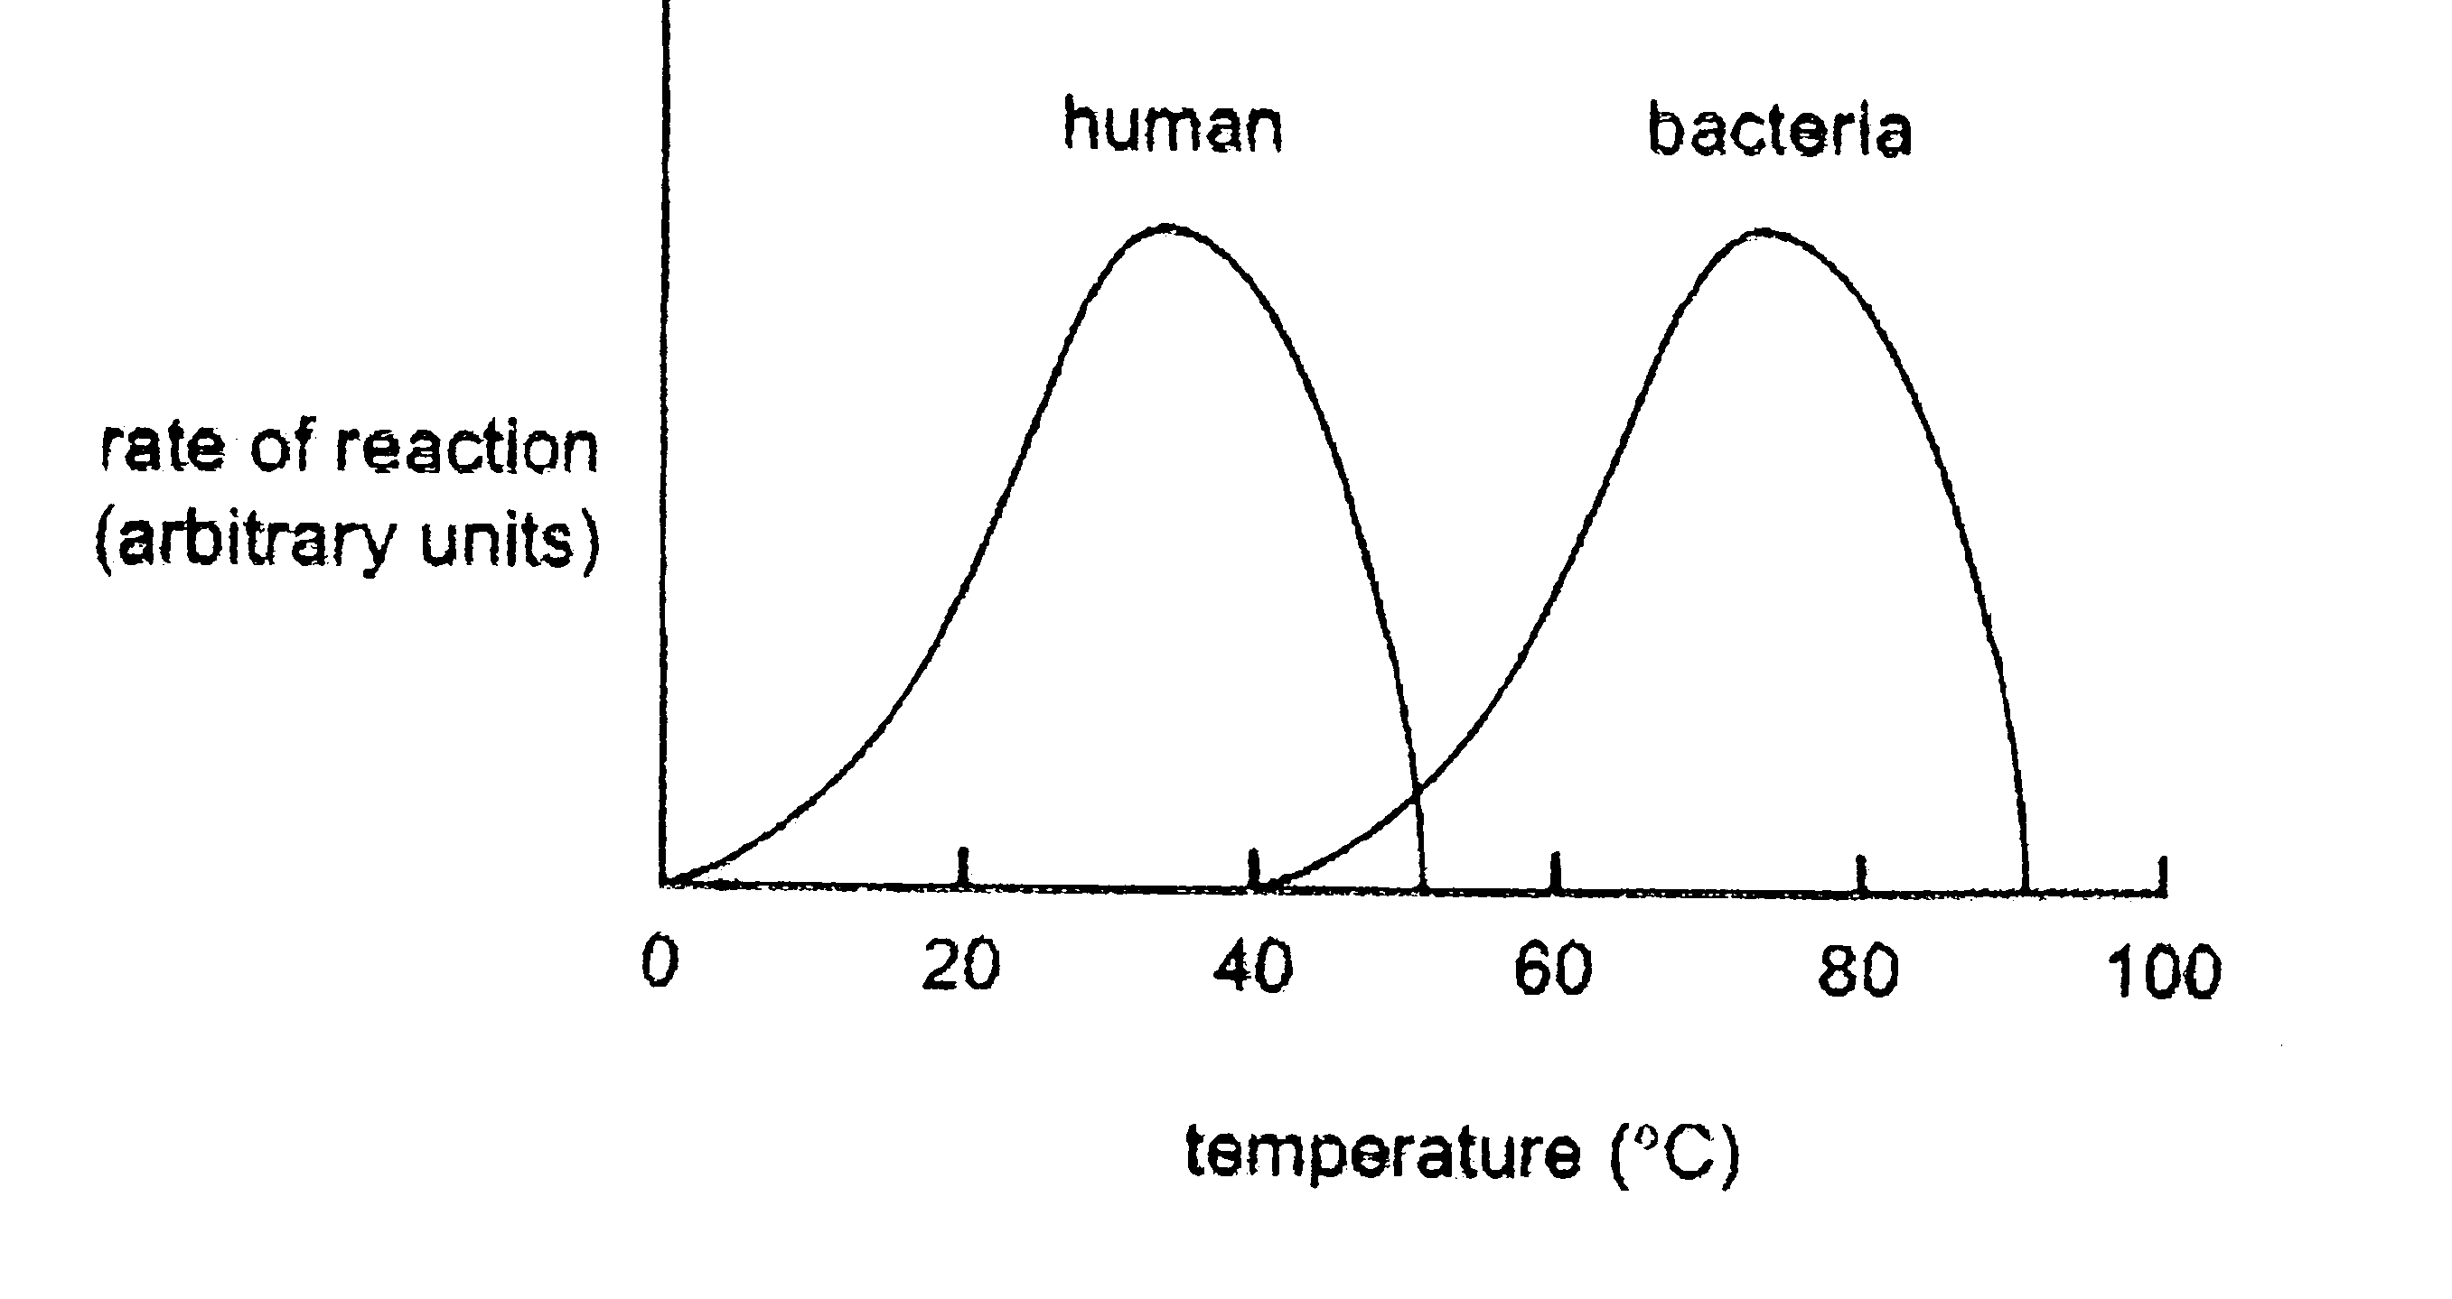

It is reasonable to conclude that;

- typical human enzymes fail to act at temperatures above 50ºC
- the optimal temperature for enzymes for both organisms is about 37ºC
- a denatured bacterial enzyme would resume activity if reincubated at 40ºC
- enzymes from bacteria that live in hot springs withstand temperatures up to 100ºC

28. For optimum gas exchange, the alveoli in the lungs should have;

- thick walls that have a large surface area.
- muscular walls with the potential to expand significantly.
- large air sacs to hold more air.
- thin walls with the maximum possible surface area.

29. A student is using a microscope with a 10X ocular lens. His high power objective lens is 40X and
the field of view is 325um. He then changes to a low power objective lens of 10X. What is the
‘field of view’ at low power?

- 0.65mm
- 0.82mm
- 1.30mm
- 1.64mm

30. After blood has passed through the kidney, useful substances inside the filtrate can still be
retained by;

- filtration.
- selective reabsorption.
- active secretion.
- diffusion.

End of Section One

Section Two: Short answer 50% (100 marks)

This section has nine (9) questions. Write your answers in the space provided.

Spare pages are included at the end of this booklet. They can be used for planning your responses and/or
as additional space if required to continue an answer.

Suggested working time for this section is 90 minutes.

_____________________________________________________________________________________

Question 31 (12 marks)

(a) Chemical reactions in the body can be classed as catabolic or anabolic. Describe the difference
between these two types of reactions. (1 mark)

_______________________________________________________________________________

_______________________________________________________________________________

_______________________________________________________________________________

(b) Explain how enzymes can speed up chemical reactions. (2 marks)

_______________________________________________________________________________

_______________________________________________________________________________

_______________________________________________________________________________

(c) In the space below, draw a labelled diagram showing the three stages of enzyme action in the lock
and key model. (5 marks)

(d) Explain how the following factors can affect enzyme activity.

(i) Temperature (2 marks)

_________________________________________________________________________

_________________________________________________________________________

_________________________________________________________________________

_________________________________________________________________________

(ii) Co-factors (2 marks)

_________________________________________________________________________

_________________________________________________________________________

_________________________________________________________________________

_________________________________________________________________________

Question 32 (11 marks)

This question refers to the diagram shown below.
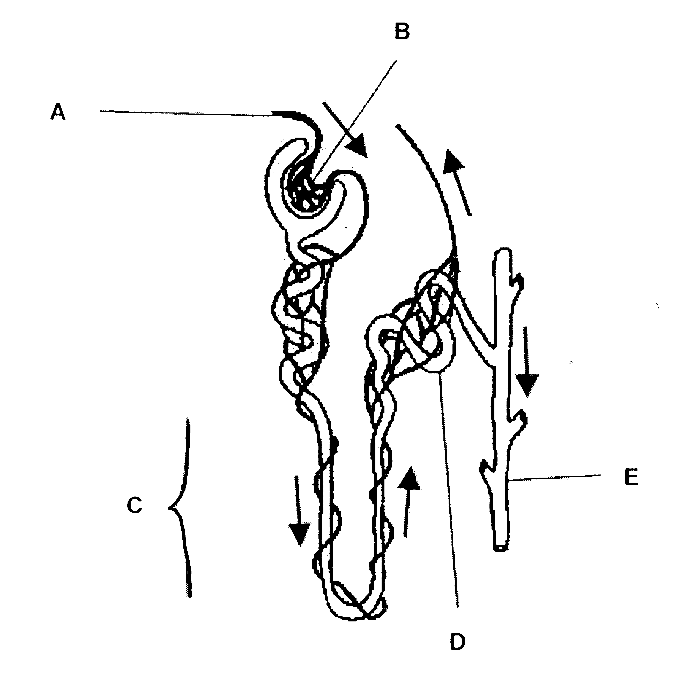

a) (i) The structure shown in the diagram is known as the functional unit of the kidney.
What is it called? (1 mark)

_________________________________________________________________________

(ii) Identify the parts listed below. (2 marks)

B: ______________________________________________________________________

E: ______________________________________________________________________

(iii) State the function of the parts listed below. (2 marks)

A: ______________________________________________________________________

C: ______________________________________________________________________

(iv) Explain why structure D is convoluted rather than being a straight tube. (1 mark)

_________________________________________________________________________

_________________________________________________________________________

_________________________________________________________________________

(b) What is deamination and where does it occur in the human body? (2 marks)

_______________________________________________________________________________

_______________________________________________________________________________

_______________________________________________________________________________

(c) Describe the two (2) stages involved in the process of deamination and the fate of its by-products.
(3 marks)

_______________________________________________________________________________

_______________________________________________________________________________

_______________________________________________________________________________

_______________________________________________________________________________

_______________________________________________________________________________

_______________________________________________________________________________

Question 33 (9 marks)

(a) (i) Describe the three (3) specific ways carbon dioxide is transported in the blood. (3 marks)

_________________________________________________________________________

_________________________________________________________________________

_________________________________________________________________________

_________________________________________________________________________

_________________________________________________________________________

_________________________________________________________________________

(ii) Which one of the three ways identified in part a (i) is the main way carbon dioxide is
transported in the blood? (1 mark)

_________________________________________________________________________

(b) Mrs Smith accidentally pricked her right thumb when trimming a rose plant. The injured area
became swollen, red and slightly tender to touch.

(i) What is this reaction to injury called? (1 mark)

_________________________________________________________________________

(ii) Explain why the injured tissue becomes swollen and red. (4 marks)

_________________________________________________________________________

_________________________________________________________________________

_________________________________________________________________________

_________________________________________________________________________

_________________________________________________________________________

_________________________________________________________________________

_________________________________________________________________________

_________________________________________________________________________

Question 34 (14 marks)

The diagram shown below is a representation of the human digestive system.
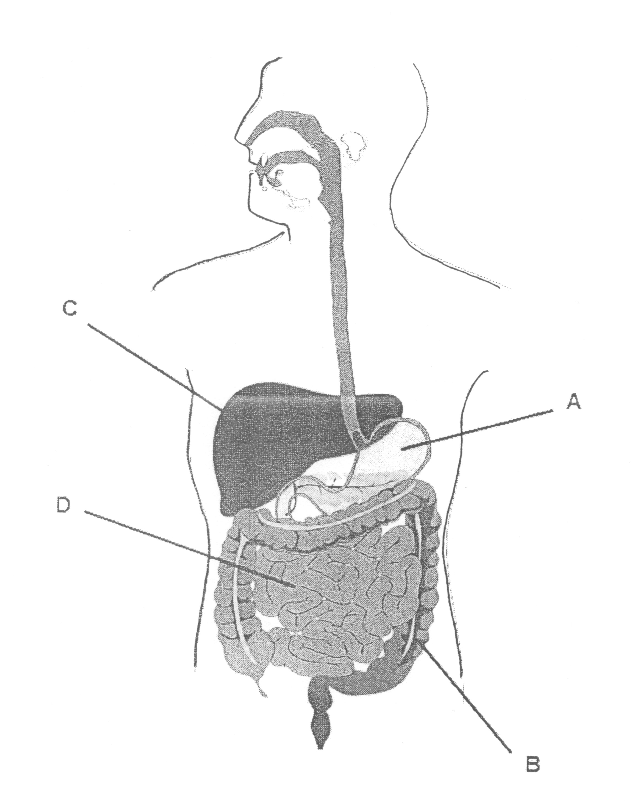

(a) Identify the parts listed below. (2 marks)

A: ____________________________________________________________________________

C: ____________________________________________________________________________

(b) State one (1) function of the parts listed below, related to digestion and absorption of food.
(2 marks)

A: ____________________________________________________________________________

D: ____________________________________________________________________________

(c) State the sources of the digestive enzyme amylase. Describe the specific role of amylase in the
digestion process. (3 marks)

_______________________________________________________________________________

_______________________________________________________________________________

_______________________________________________________________________________

_______________________________________________________________________________

_______________________________________________________________________________

_______________________________________________________________________________

The diagram below illustrates an intestinal villus.
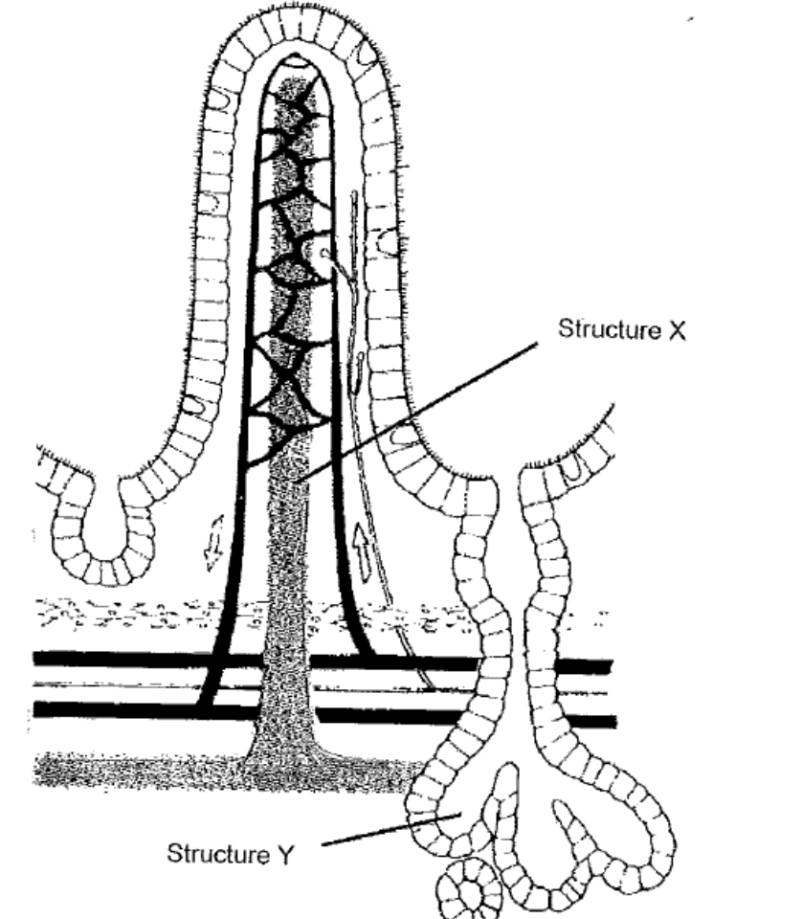

(d) Identify the part labelled X and state its function. (2 marks)

_______________________________________________________________________________

_______________________________________________________________________________

_______________________________________________________________________________

_______________________________________________________________________________

(e) Identify the part labelled Y and state its function. (2 marks)

_______________________________________________________________________________

_______________________________________________________________________________

_______________________________________________________________________________

_______________________________________________________________________________

(f) Peristalsis is a form of mechanical digestion. (3 marks)

(i) In the space provided in the table below, name one (1) other example of mechanical digestion.

(ii) In the table, contrast these two processes in terms of where they occur (ii) and the
function of the process (iii).

 | Peristalsis | (i) ____________________________
(ii)
Where it
occurs

(iii)
Function

Question 35 (10 marks)

A drug company wishing to exploit the increased levels of Antarctic exploration decided to design and
test a drug that would improve the efficiency of the respiratory system under stressful conditions such as
extremely cold environments. 80 scientists who regularly visit Antarctica volunteered to test the drug and
were divided into two equal groups.

The data obtained from one of their investigations is presented below.

 | No drug administered | Drug administered
Environmental  Temperature  (ºC) | Breathing rate  (breaths per minute) | Breathing rate  (breaths per minute)
5 | 24 | 20
15 | 17 | 15
18 | 18 | 15
22 | 20 | 20
25 | 20 | 21
35 | 30 | 26

(a) Consider the hypothesis:

‘The new drug will increase breathing rates at low environmental temperature’

Identify the independent and dependent variables in this investigation. (2 marks)

Independent: ____________________________________________________________________

Dependent: _____________________________________________________________________

(b) List two (2) variables that should be controlled in this investigation. (2 marks)

_______________________________________________________________________________

_______________________________________________________________________________

(c) Graph the data obtained for the effect of the drug on breathing rate. (4 marks)

(If you wish to have a second attempt at the graph, the grid is repeated at the end of this Question/
Answer Booklet. Indicate clearly on this page if you have used the second grid and cancel the
working on the grid on this page.)

(d) The scientists were concerned that a virus caught by some of the subjects during the
investigation may have affected the data. Explain how a well designed investigation could avoid
the effect of such issues. (2 marks)

_______________________________________________________________________________

_______________________________________________________________________________

_______________________________________________________________________________

_______________________________________________________________________________

_______________________________________________________________________________

Question 36 (9 marks)

A scientist set up the equipment shown below;

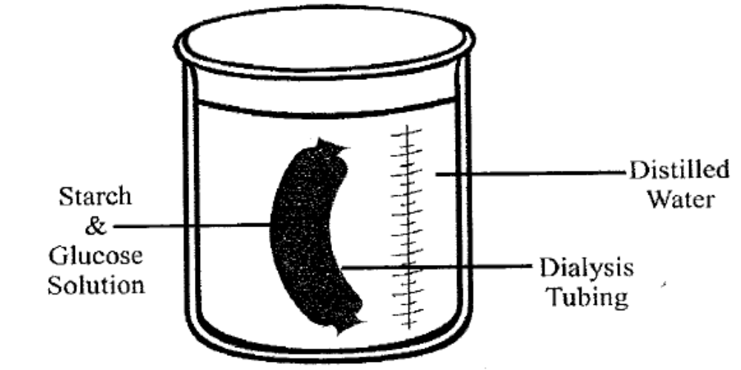

Dialysis tubing was knotted at one end and then filled with a mixture of starch and glucose in solution. The outside of the tubing was washed before being placed in a beaker filled with distilled water. Immediately after the tubing was placed in a beaker, a sample of the distilled water was taken and tested for both starch and glucose. The distilled water was tested again after 25 minutes had elapsed.

(a) List two (2) ways in which the alimentary canal differs from the model represented here.
(2 marks)

_______________________________________________________________________________

_______________________________________________________________________________

(b) Why was the tubing washed after being filled? (1 mark)

_______________________________________________________________________________

_______________________________________________________________________________

(c) Describe how the scientist would have tested for starch and explain what he/she would see if a
positive result occurred. (2 marks)

_______________________________________________________________________________

_______________________________________________________________________________

_______________________________________________________________________________

_______________________________________________________________________________

_______________________________________________________________________________

(d) (i) What results would you expect when the water was tested at 25 minutes? (2 marks)

_________________________________________________________________________

_________________________________________________________________________

_________________________________________________________________________

_________________________________________________________________________

(ii) Explain why you would get these results. (2 marks)

_________________________________________________________________________

_________________________________________________________________________

_________________________________________________________________________

_________________________________________________________________________

Question 37 (14 marks)

(a) Name a blood vessel that would have: (3 marks)

(i) the highest oxygen concentration.

_________________________________________________________________________

(ii) the highest concentration of glucose following a meal.

_________________________________________________________________________

(iii) blood at high pressure and with a high carbon dioxide level.

_________________________________________________________________________

(b) Explain why the heart and aorta are both considered to be organs. (1 mark)

_______________________________________________________________________________

_______________________________________________________________________________

_______________________________________________________________________________

The diagram below shows a sample of blood.
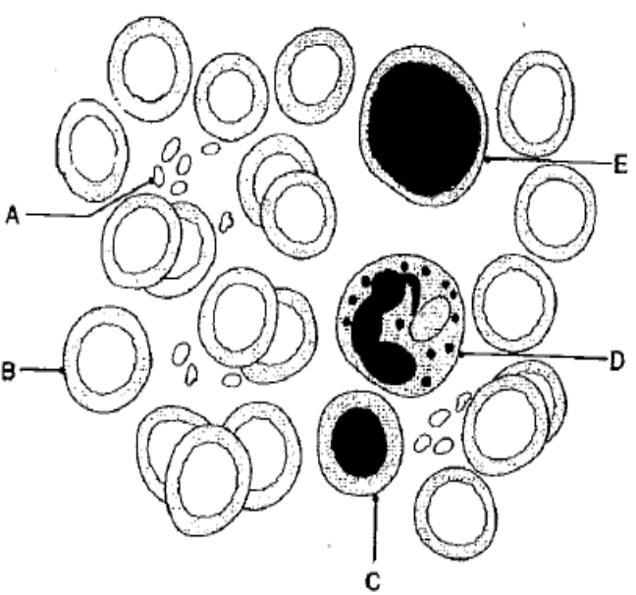

(c) (i) Differentiate between the structure of A and B. (1 mark)

_______________________________________________________________________

_______________________________________________________________________

_______________________________________________________________________

(ii) What general name could be given to the three cells C, D and E? (1 mark)

_________________________________________________________________________

_________________________________________________________________________

(iii) Differentiate between the functions of cell B and cell D. (1 mark)

_________________________________________________________________________

_________________________________________________________________________

_________________________________________________________________________

(iv) Name one (1) liquid that cell D would be found in but cell B would not. (1 mark)

_________________________________________________________________________

_________________________________________________________________________

The diagram below illustrates a heart.
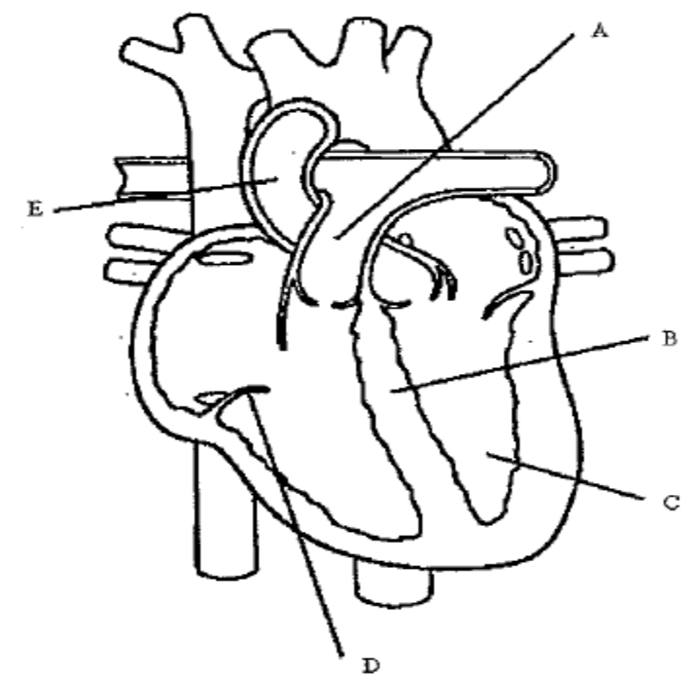

(d) (i) Name the structures labelled in the diagram above: (3 marks)

A: ______________________________________________________________________

B: ______________________________________________________________________

C: ______________________________________________________________________

(ii) What is the function of the following structures? (2 marks)

B: ______________________________________________________________________

D: ______________________________________________________________________

(iii) Structure A directs blood towards the: (1 mark)

_________________________________________________________________________

Question 38 (16 marks)

The diagrams below show the respiratory system in two different stages.

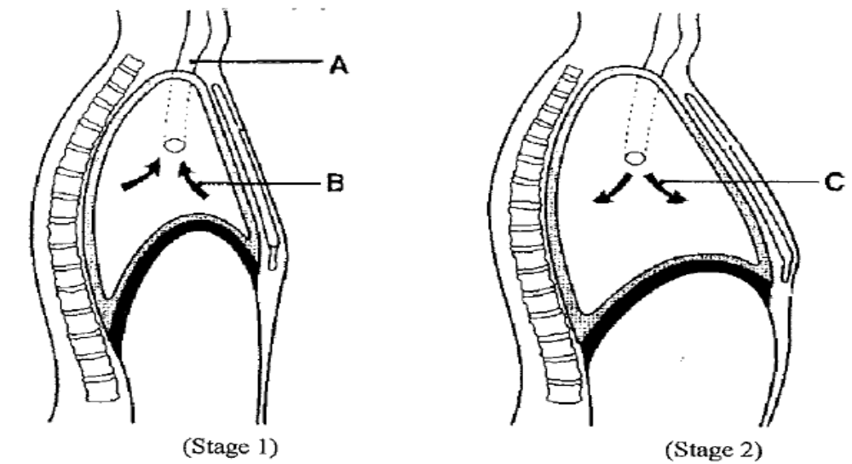

(a) Name Stage 1. (1 mark)

_______________________________________________________________________________

(b) Describe the processes involved for Stage 2 to occur. (3 marks)

_______________________________________________________________________________

_______________________________________________________________________________

_______________________________________________________________________________

_______________________________________________________________________________

(c) How is structure A suited to the function it performs? (2 marks)

_______________________________________________________________________________

_______________________________________________________________________________

_______________________________________________________________________________

_______________________________________________________________________________

(d) How is the air at B similar to the air at C? (1 mark)

_______________________________________________________________________________

_______________________________________________________________________________
(e) How is the air at B different to the air at C? (2 marks)

_______________________________________________________________________________

_______________________________________________________________________________

_______________________________________________________________________________

The diagram below shows the structural relationship between an alveolus and a blood capillary.
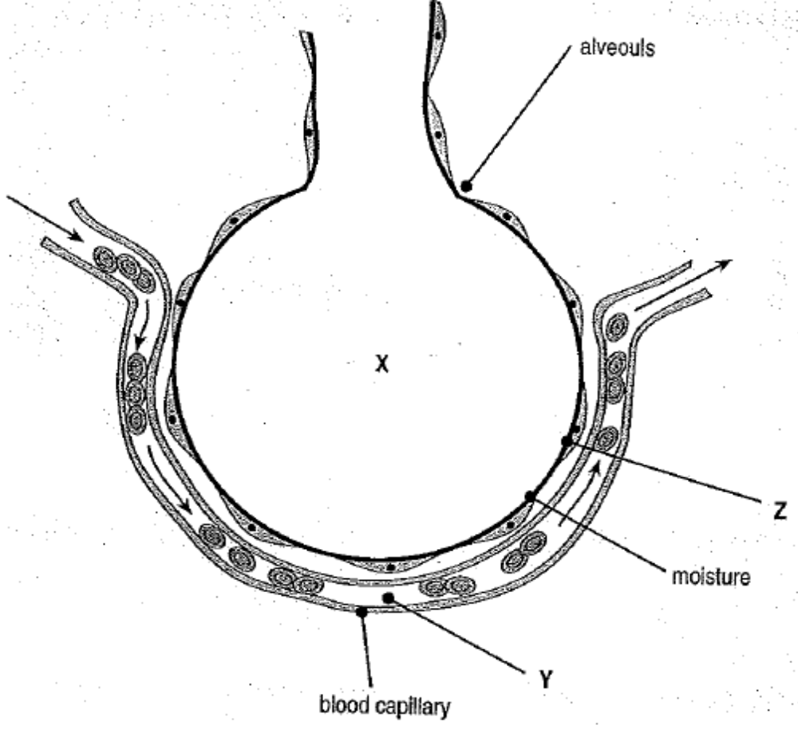

(f) After inhalation, explain why oxygen moves from X to Y and carbon dioxide from Y to X.
(2 marks)

_______________________________________________________________________________

_______________________________________________________________________________

_______________________________________________________________________________

_______________________________________________________________________________

_______________________________________________________________________________

(g) As the oxygen moves into the blood plasma, how does it travel in the blood? (2 marks)

_______________________________________________________________________________

_______________________________________________________________________________

_______________________________________________________________________________

(h) Why must the lining of the alveolus (Z) remain moist? (1 mark)

_______________________________________________________________________________

_______________________________________________________________________________

(i) What special features of the alveoli allow efficient oxygen exchange?
(2 marks)

_______________________________________________________________________________

_______________________________________________________________________________

_______________________________________________________________________________

_______________________________________________________________________________

Question 39 (5 marks)

The diagram below shows the fluid mosaic model of membrane structure.

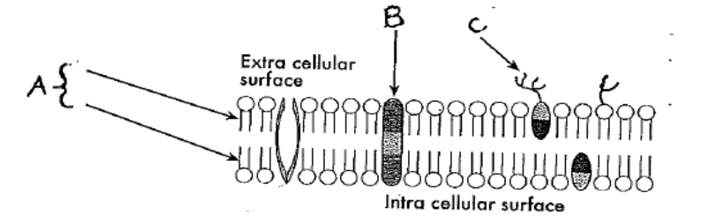

(a) Name the structures shown in the diagram above; (3 marks)

A: ____________________________________________________________________________

B: ____________________________________________________________________________

C: ____________________________________________________________________________

(b) Explain the ‘fluid mosaic’ model of the cell membrane. (2 marks)

_______________________________________________________________________________

_______________________________________________________________________________

_______________________________________________________________________________

_______________________________________________________________________________

_______________________________________________________________________________

End of Section Two

Section Three: Extended answer 20% (20 marks)

This section contains two (2) questions. You must answer one (1) question. You can choose question 40
or question 41. Write your answers in the space provided.

Spare pages are included at the end of this booklet. They can be used for planning your response and/or
as additional space if required to continue an answer.

Responses could include clearly labelled diagrams with explanatory notes; lists of points with linking
sentences; clearly labelled tables and graphs; and annotated flow diagrams with introductory notes.

Suggested working time for this section is 25 minutes.

_____________________________________________________________________________________

Question 40 (20 marks)

(a) Cells experience a constant exchange of materials with their environment. Identify two (2) passive
methods by which cells transport materials across their membranes. Describe these two methods
and explain the factors that affect their action. (6 marks)

(b) Identify the structures that have a role in the movement of air into the lungs. Describe the role
played by each structure. (10 marks)

(c) Describe two (2) lifestyle choices that can have a negative impact on an individual’s physical
fitness. (4 marks)

OR

Question 41 (20 marks)

(a) The human body is surrounded by and in contact with countless micro-organisms (bacterial,
fungal, viral, protozoan). Discuss the non-specific methods of defence indicating briefly how each
method protects the body. (10 marks)

(b) A single-celled animal does not require a circulatory system and yet large, multi-cellular animals
do.
(i) Explain why this is so. (2 marks)

(ii) Explain how the human circulatory system delivers oxygen and nutrients to and
removes wastes from the cells of the human body. (8 marks)

End of questions

___________________________________________________________________________________________________________________________________________________________________________________________________________________________________________________________________________________________________________________________________________________________________________________________________________________________________________________________________________________________________________________________________________________________________________________________________________________________________________________________________________________________________________________________________________________________________________________________________________________________________________________________________________________________________________________________________________________________________________________________________________________________________________________________________________________________________________________________________________________________________________________________________________________________________________________________________________________________________________________________
_______________________________________________________________________________________________________________________________________________________________________________________________________________________________________________________________________________________________________________________________________________________________________________________________________________________________________________________________________________________________________________________________________________________________________________________________________________________________________________________________________________________________________________________________________________________________________________________________________________________________________________________________________________________________________________________________________________________________________
__________________________________________________________________________________________________________________________________________________________________________________________________________________________________________________________________________________________________________________________________________________________________________________________________________________________________________________________________________________________________________________________________________________________________________________________________________________________________________________________________________________________________________________________________________________________________________________________________________________________________________________________________________________________________________________________________________________________________________________________________________________________________________________________________________________________________________________________________________________________________________________________________________________________________________________________________________________________________________________________
_______________________________________________________________________________________________________________________________________________________________________________________________________________________________________________________________________________________________________________________________________________________________________________________________________________________________________________________________________________________________________________________________________________________________________________________________________________________________________________________________________________________________________________________________________________________________________________________________________________________________________________________________________________________________________________________________________________________________________
__________________________________________________________________________________________________________________________________________________________________________________________________________________________________________________________________________________________________________________________________________________________________________________________________________________________________________________________________________________________________________________________________________________________________________________________________________________________________________________________________________________________________________________________________________________________________________________________________________________________________________________________________________________________________________________________________________________________________________________________________________________________________________________________________________________________________________________________________________________________________________________________________________________________________________________________________________________________________________________________
_______________________________________________________________________________________________________________________________________________________________________________________________________________________________________________________________________________________________________________________________________________________________________________________________________________________________________________________________________________________________________________________________________________________________________________________________________________________________________________________________________________________________________________________________________________________________________________________________________________________________________________________________________________________________________________________________________________________________________
__________________________________________________________________________________________________________________________________________________________________________________________________________________________________________________________________________________________________________________________________________________________________________________________________________________________________________________________________________________________________________________________________________________________________________________________________________________________________________________________________________________________________________________________________________________________________________________________________________________________________________________________________________________________________________________________________________________________________________________________________________________________________________________________________________________________________________________________________________________________________________________________________________________________________________________________________________________________________________________________
_______________________________________________________________________________________________________________________________________________________________________________________________________________________________________________________________________________________________________________________________________________________________________________________________________________________________________________________________________________________________________________________________________________________________________________________________________________________________________________________________________________________________________________________________________________________________________________________________________________________________________________________________________________________________________________________________________________________________________
__________________________________________________________________________________________________________________________________________________________________________________________________________________________________________________________________________________________________________________________________________________________________________________________________________________________________________________________________________________________________________________________________________________________________________________________________________________________________________________________________________________________________________________________________________________________________________________________________________________________________________________________________________________________________________________________________________________________________________________________________________________________________________________________________________________________________________________________________________________________________________________________________________________________________________________________________________________________________________________________
_______________________________________________________________________________________________________________________________________________________________________________________________________________________________________________________________________________________________________________________________________________________________________________________________________________________________________________________________________________________________________________________________________________________________________________________________________________________________________________________________________________________________________________________________________________________________________________________________________________________________________________________________________________________________________________________________________________________________________

